Lab2: Python Basics for Machine Learning

Student Number: 41273681
Student Name: Olamilekan Elegbede

Each Python Code must include a Markdown section explain the following code.

Q1: Write a python code To Display Your First Name, Last Name, and Student Number. Place a screenshot showing the Markdown, Code, and Output here
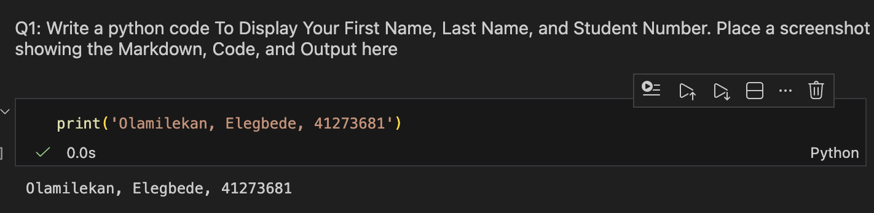

Q2: Write a python code that converts a temperature from Fahrenheit (°F) to Celsius (°C).
Steps:
- Take the Fahrenheit input from the user
- Do the Maths
- Print out the converted temperature in Celsius
Use the following formula and write it out in Python:
Celsius = (Fahrenheit − 32) / 1.8

Place a screenshot showing the Markdown, Code, and Output here. The Output shall Include your Student number as well.

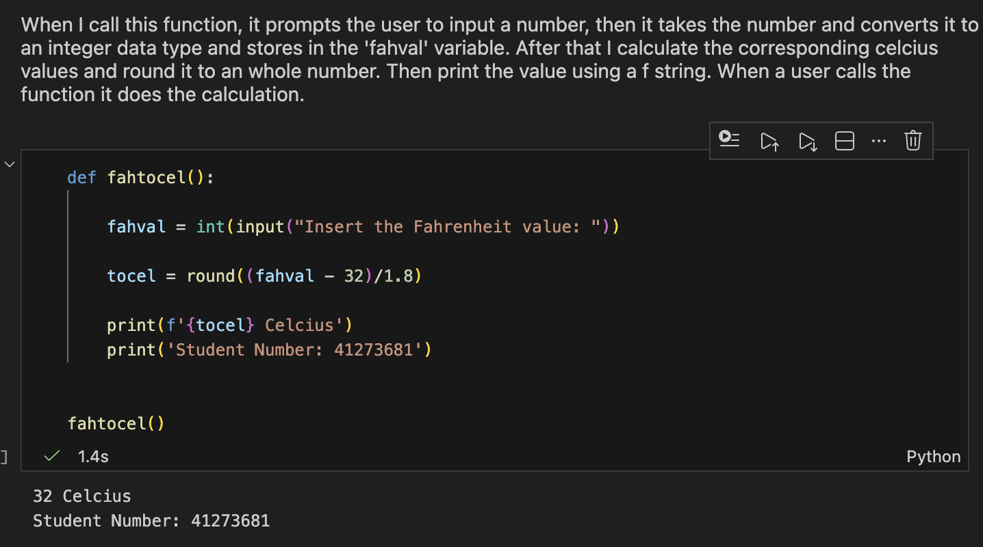
Q3: Create a Dictionary Item with your Student Name and Student number.
Steps
- Include 5 keys (Student Number, Name, Program, Courses, Instructors) and corresponding values.
- Print the courses you are taking
- Display your Student Name using a dictionary method “get”
- Display all the values using Dictionary function “values”
Place a screenshot showing the Markdown, Code, and Output here.
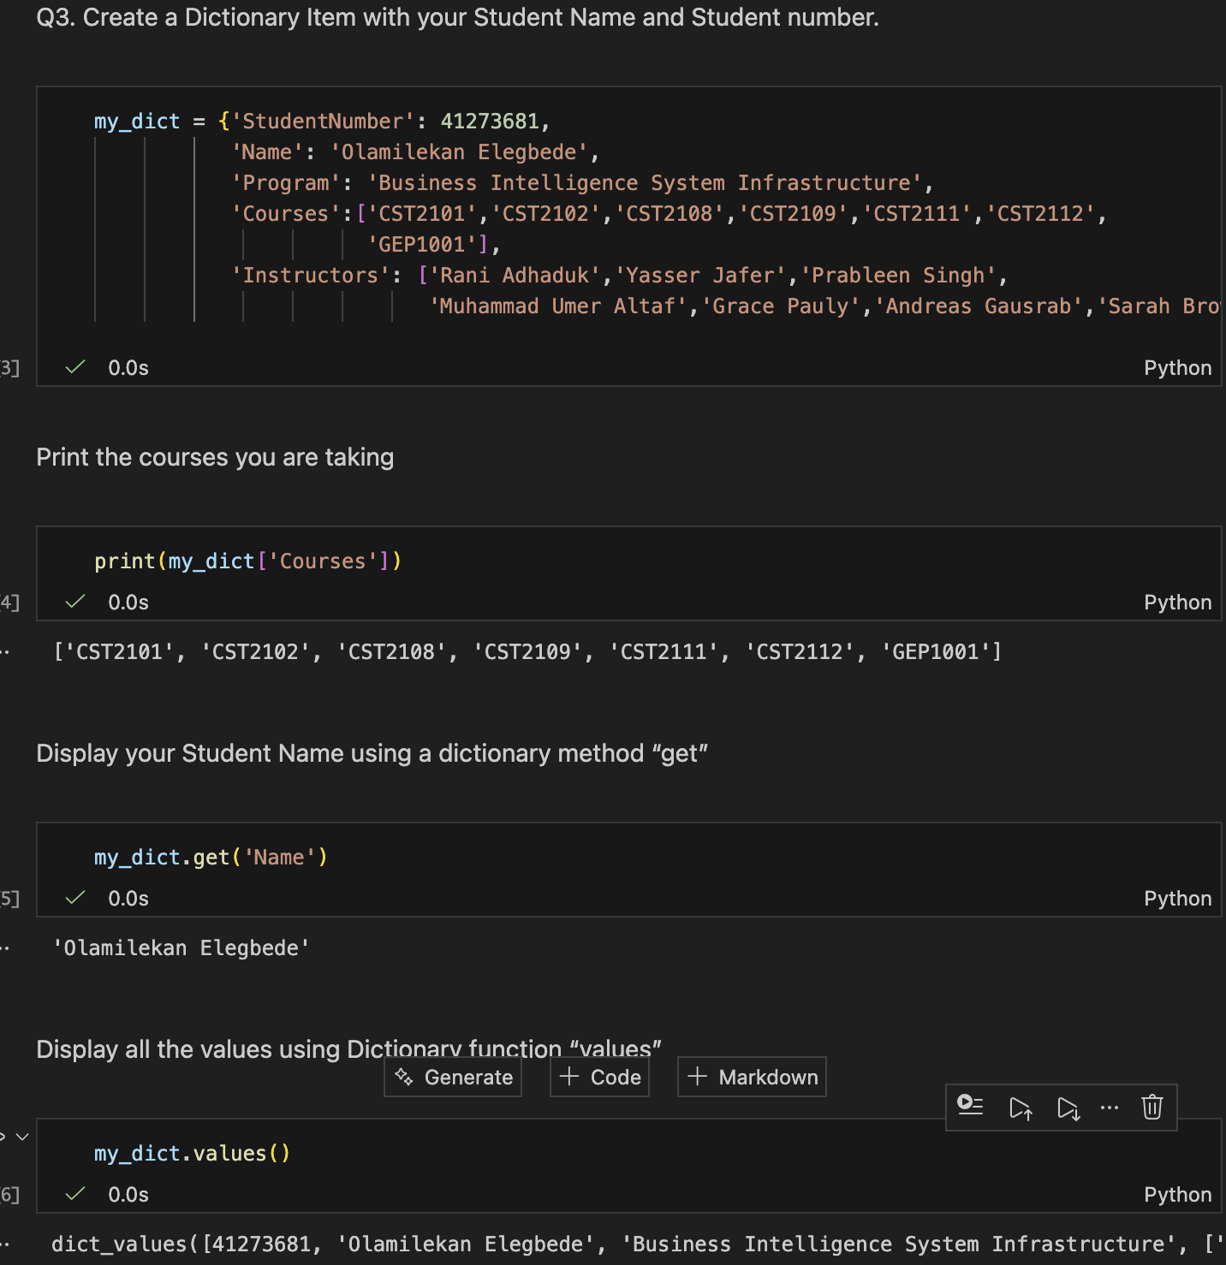
Q4. Fizz Buzz is a children's word game that teaches division. It's also a classic technical interview question.
Write a program that outputs numbers from 1 to 10. Here's the catch:
- For multiples of 2, print Fizz instead of the number.
- For multiples of 5, print Buzz instead of the number.
- For multiples of 2 and 5, print FizzBuzz.
Expected output:
1 Fizz 3 Fizz Buzz Fizz 7 Fizz 9 FizzBuzz
Place a screenshot showing the Markdown, Code, and Output here.

